Maxwell Maia 21236277 2022 Semester 2

CT102: Algorithms

Assignment 1

**Question 1**

sizeA = N

sizeB = M

|  |  |  |  |  |
| --- | --- | --- | --- | --- |
| Line | Cost | numTimes | cost*numTimes | Total |
| 24 | 1 | 1 | 1 |  |
| 25 | 1 | 1 | 1 |  |
| 27 | 1 | N + M + 1 | N + M + 1 |  |
| 28 | 1 | N + M | N + M |  |
| 29 | 1 | N | N |  |
| 31 | 1 | N + M | N + M |  |
| 32 | 1 | M | M |  |
| 40 | 1 | 1 | 1 |  |
|  |  |  |  | a) 4N + 4M + 4 |

b) O(N + M). Even though we are comparing two functions, it is a linear function because N and M is to the power of 1.

**Question 2**

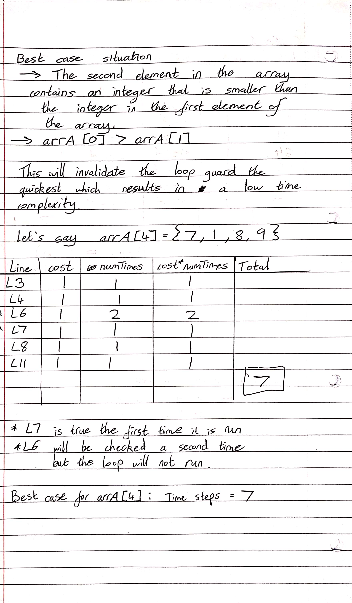

**Question 2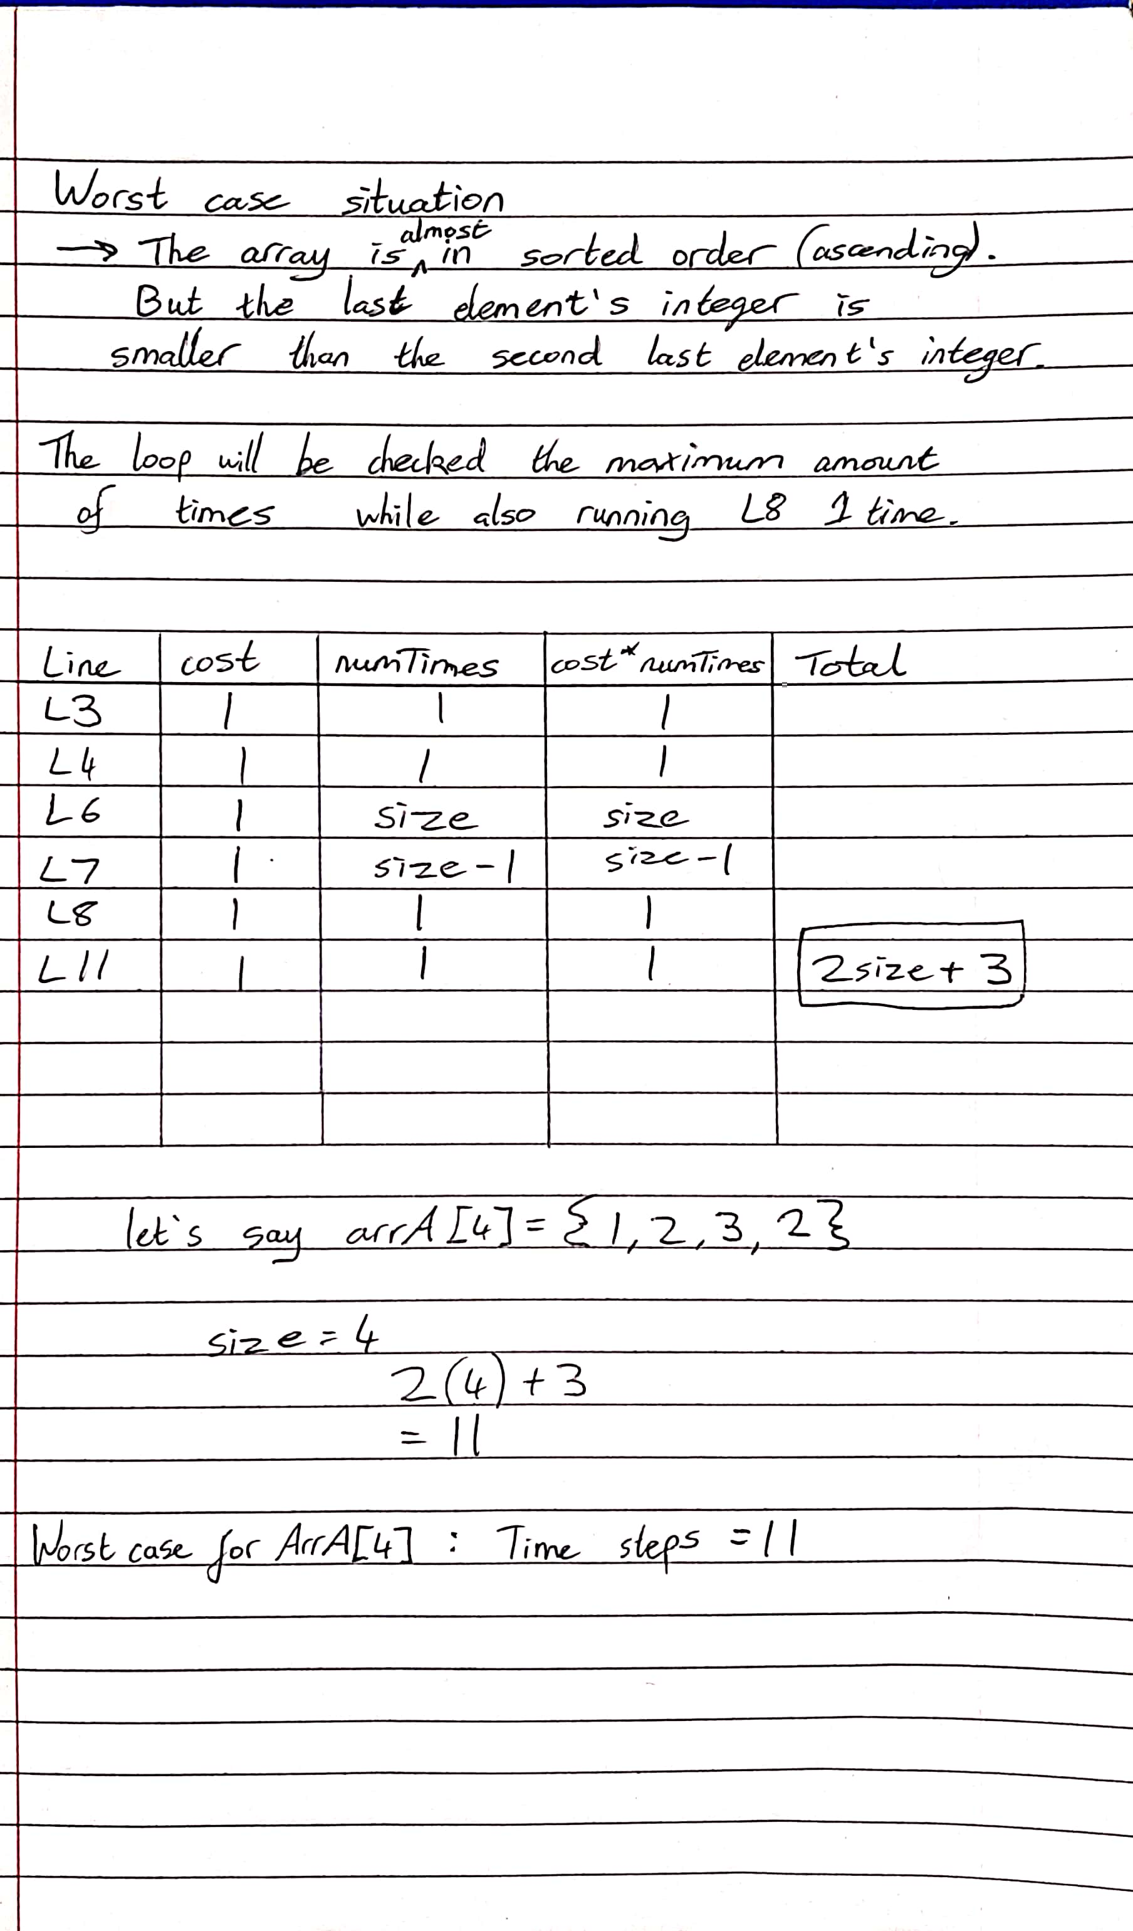 continued…**

**Question 3 —** **output screenshots**

a) 5000Ints.txt

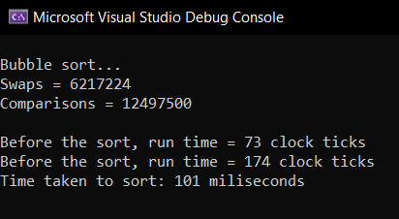

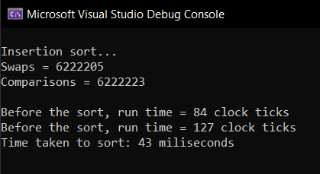

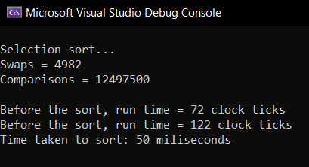

**Question 3 —more output screenshots**

b) 5000sortedInts.txt

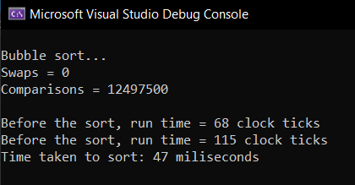

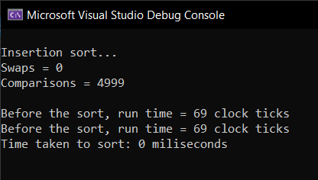

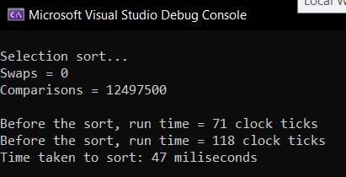

**Question 3 — Summary**

|  |  |  |  |  |  |  |
| --- | --- | --- | --- | --- | --- | --- |
|  | Situation 1: Unsorted array  (a) 5000Ints.txt | | | Situation 2: Sorted array  (b) 5000sortedInts.txt | | |
|  |  | | |  | | |
|  | **Bubble** | **Insertion** | **Selection** | **Bubble** | **Insertion** | **Selection** |
| Swaps | 6 217 224 | 6 222 205 | 4 982 | 0 | 0 | 0 |
| Comparisons | 12 497 500 | 6 222 223 | 12 497 500 | 12 497 500 | 4 999 | 12 497 500 |
| Time taken (ms) | 101 | 43 | 50 | 47 | 0 | 47 |

**Points made from summary**

Bubble sort is the slowest function with a high number of swaps and a high number of comparisons

Insertion sort performs slightly more swaps but less comparisons.

Selection sort performs significantly less swaps but the same amount of comparisons as bubble sort.

Bubble sort and selection sort do not take full advantage of sorted data to increase efficiency. Insertion, however, takes advantage of sorted data by performing less comparisons which results in a lower time to sort.

**Conclusion**

Insertion sort is the best sort for unsorted and sorted data out of these 3 functions.

**Question 4**

Plagiarism Declaration: “I am aware of what plagiarism is and include this here to confirm that this work is my own”